10 YEARS OF THE TSIRY PROJECT: REVIEW AND OUTLOOK
When the Tsiry project started in autumn 2010 with the training of the teachers, nobody had any idea how long-term, successful, and sustainable the programme would be. By the summer of 2020, 5173 adults and 2180 children, including 1283 girls, had participated in 11 locations for adults (AFID), and 7 locations for children (ASAMA).
In the last school year, the courses were again largely completed despite the COVID-19 pandemic. Masks were donated to adults and children, and teachers and pupils were taught hygiene rules.
ASAMA classes for children
Classes for 220 children started at seven locations in November 2019 and ended with the CEPE exam (basic education exam) in September 2020, which was delayed due to COVID-19. The teachers are proud that the children from the Tsiry programme have a success rate of 69%, which is better than that of pupils in public schools - despite the fact that lessons were cancelled due to COVID-19 and the fact that the children come from disadvantaged families and their parents often cannot read and write themselves.
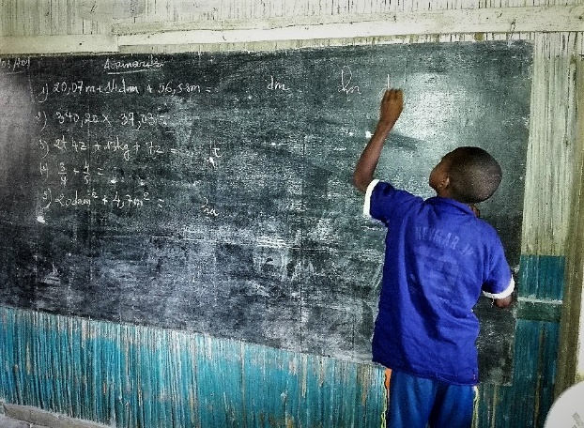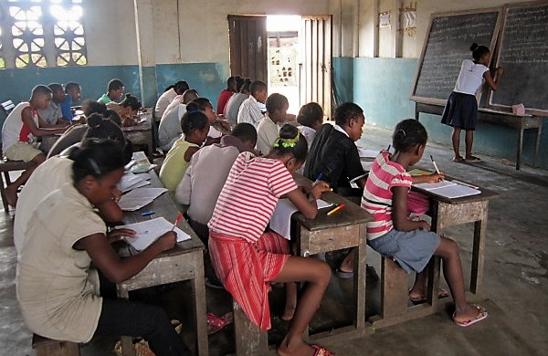
The children continued to receive meals from the school kitchens during the cutbacks in lessons. The food was cooked by the mothers.
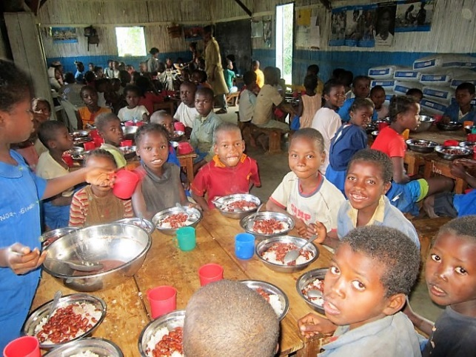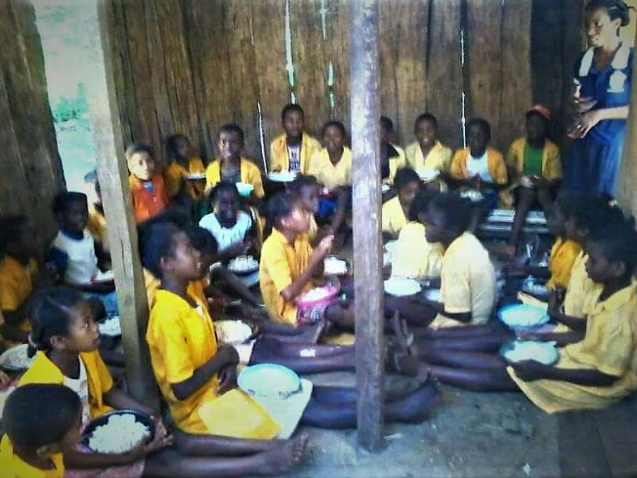
AFID classes for adults
After the successful completion of the 14th course, the 15th course started in February 2020 at 11 locations with 336 participants, although it had to be interrupted in March due to COVID-19. From May onwards, the courses started again in compliance with the distancing rules.
The classrooms were equipped accordingly by the local committees (churches, public schools, community centres, private houses). The instructors continued to visit the teachers and train them in COVID-19 prevention measures. Classes were held 3 or 4 days a week and were based on the working hours of the participants. All this meant that the programme could be carried out and 220 participants received their diploma.
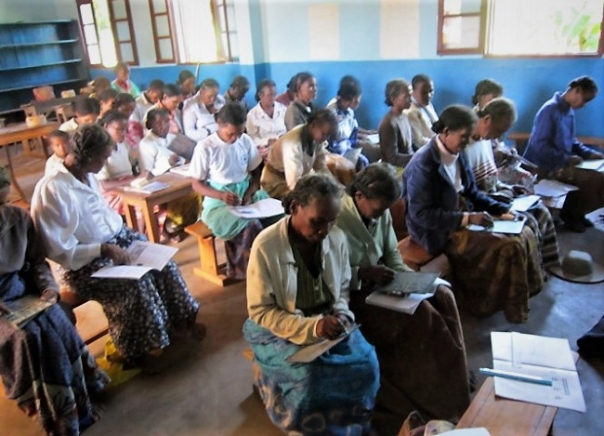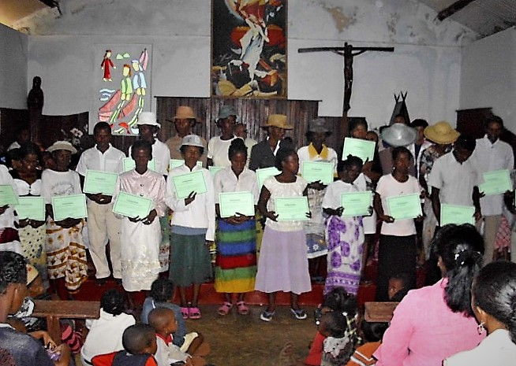
Economic development
This part of the project is particularly important because the COVID-19 crisis hits the poorest particularly hard. Madagascar has one of the highest poverty rates in the world and it continues to rise.
In general, the participants choose activities with which they are already familiar, for example renting rice fields, which they cultivate themselves until the harvest can be sold, or micro-credit projects in which the funds are borrowed from the members and repaid after the next harvest.
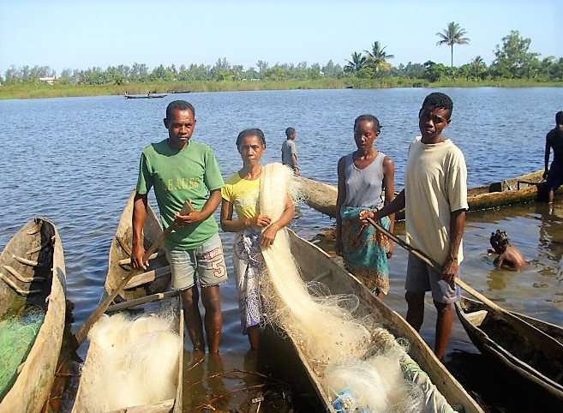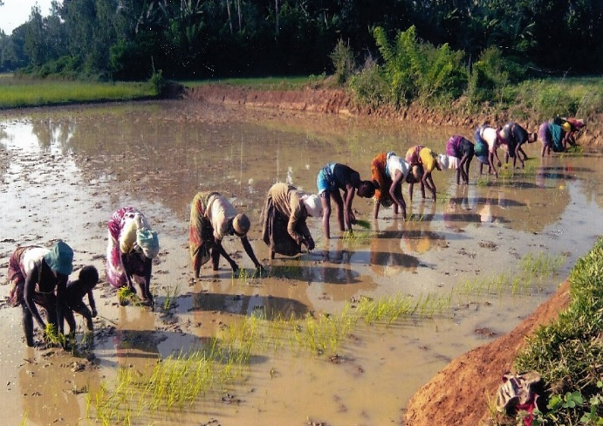

Training, exchange, and evaluation
As every year, the teachers, trainers, and the diocesan committee met in Manakara in September (AFID) and October (ASAMA) 2020. As always, the aim of the meetings was to exchange experiences between trainers and teachers. It is also a time for review, to evaluate, to see what could be improved, what problems should be solved and to discuss the results of the different sites. Overall, the teachers’ skills have been shown to be improving each year. There was also a new site, meaning that new teachers had to be trained.
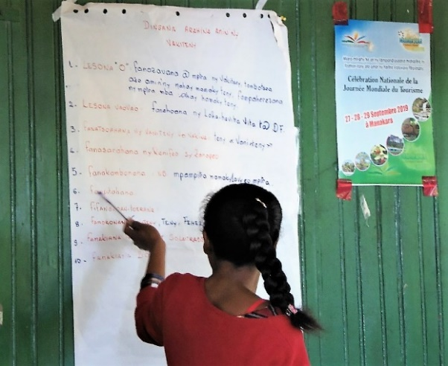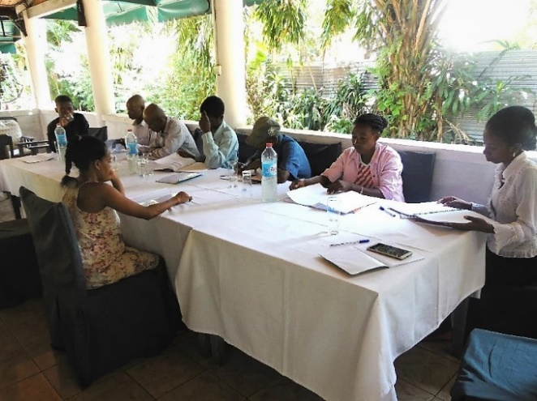

The cycle continues
The 16th course for adults (AFID) began on 12th October, while for the children (ASAMA) the new school year will start in November
We would like to say a big thank you to our donors and invite you to continue supporting this successful project, which gives hope and new prospects to so many people in difficult times.

